**Tutorial 43: Using JSON Server**

When we create websites the data is normally stored in a database and we have to fetch the data from an API endpoint. We are going to go through how we can fetch external data inside a Vue component. At the moment we will not be working with a database but instead we will be using a package called JSON server to simulate an API that we can make request to.

JSON Server basically allows us to use a simple JSON file containing data as a database resource with various different endpoints.

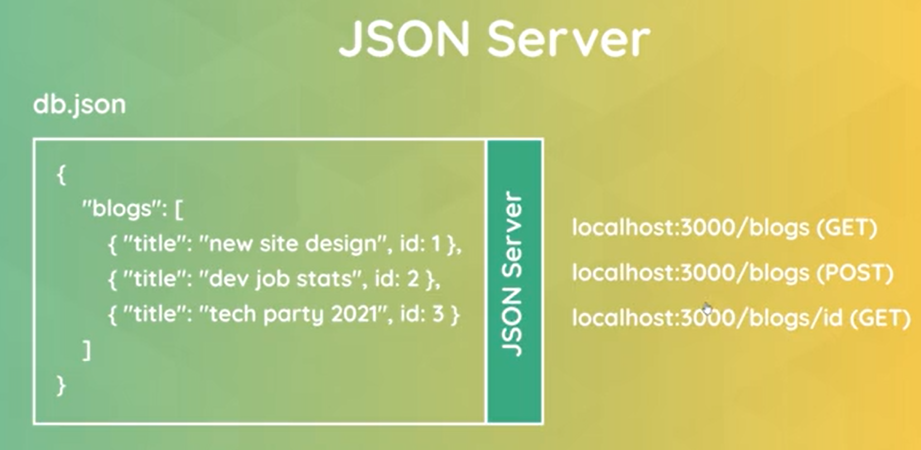

We can create a JSON file called DB JSON with blog data inside it. We would then use JSON server to watch that file and provide us with local API endpoints to interact with whatever resources we define inside that file. JSON server basically wraps our JSON file with API endpoints and gives us these endpoints so we can interact with the data.

JSON server allows us a quick and easy way to work with local data that simulates how an API behaves. Strings in a JSON file must use double quotes.

Make sure **Tutorial 42** is complete to be able to move on to this tutorial or clone the [vue3-firebase-course](https://github.com/younggrasshopperza/vue3-firebase-course) repository and go to branch called **Tutorial-42** and navigate to the young-grasshopper-jobs folder.

**Step 1:** In the root of the project, create a folder called data. Inside the folder create a db.json file. Create an object and inside the object we will have a key called jobs and it will include an array of objects which will have the job descriptions.

Look at the example below (**Line 1 and line 7**):

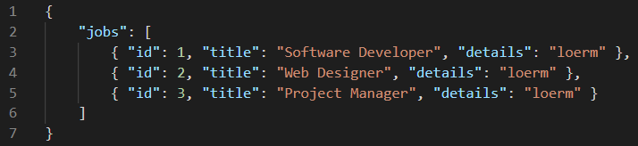

**Step 2:** Open up a new terminal so we can install a node package. Type the following command **npm install** **json-server**

The command will allow us to save the package locally in our project.

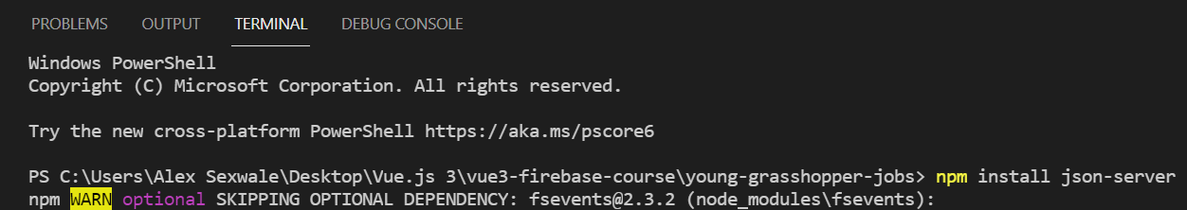

**Step 3:** Inside the terminal type, **npx json-server --watch data/db.json**

Now we can see that it is a local development server and Port 3000. The endpoint to get the job is **http://localhost:3000/jobs**

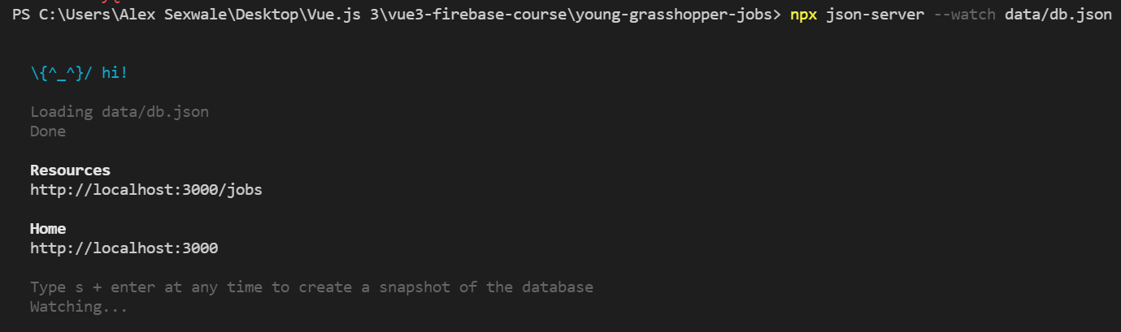

JSON server is smart enough to know that the jobs in the JSON file should create its own endpoint.

If we open up the endpoint in the browser, it is going to send a GET request and send back the JSON with all of the objects inside the array.

Type [**http://localhost:3000/jobs**](http://localhost:3000/jobs) in the browser.

**Output:**

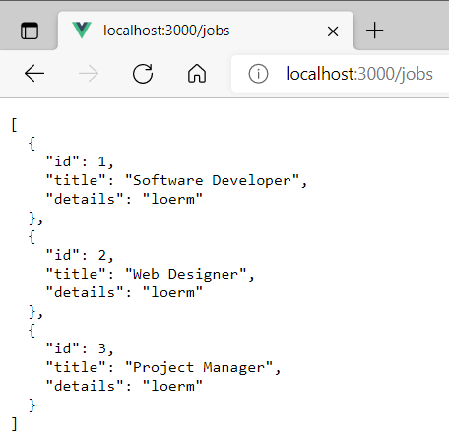

**You can view the code snippets from the** [**vue3-firebase-course**](https://github.com/younggrasshopperza/vue3-firebase-course) **repository under the Tutorial-43 branch**.